1. **For the given JSON iterate over all for loops (for, for in, for of, forEach)**

**For loop:**

**let details =**

**[{**

**1 :{person1: 600000,"age": 26,"comapny":"IBM"},**

**2 : {person2: 700000,"age": 27,"comapny":"INFOSYS"},**

**3 : {person3: 900000,"age": 25,"comapny":"WIPRO"},**

**}]**

**for (let i=0;i<details.length;i++){**

**console.log(details)**

**}**

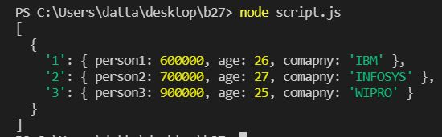

**for (let i=0;i<details.length;i++){**

**console.log(details[i]);**

**}**

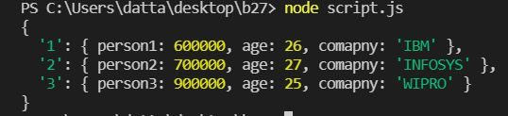

**keys = Object.keys(details);**

**for(i=0;i<keys.length;i++){**

**console.log(keys[i])**

**}**

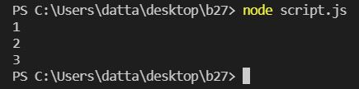

**keys = Object.keys(details);**

**for(i=0;i<keys.length;i++){**

**console.log(details[keys[i]])**

**}**

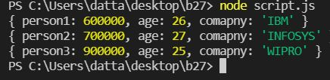

**For-in loop:**

**let details =**

**{**

**1 :{person1: 600000,"age": 26,"comapny":"IBM"},**

**2 : {person2: 700000,"age": 27,"comapny":"INFOSYS"},**

**3 : {person3: 900000,"age": 25,"comapny":"WIPRO"},**

**}**

**for(let key in details){**

**console.log(key)**

**}**

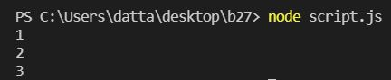

**for(let key in details){**

**console.log(details[key])**

**}**

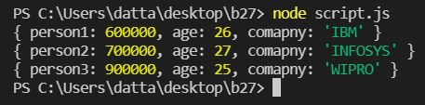

**For-of loop:**

**let details =**

**{**

**1 :{person1: 600000,"age": 26,"comapny":"IBM"},**

**2 : {person2: 700000,"age": 27,"comapny":"INFOSYS"},**

**3 : {person3: 900000,"age": 25,"comapny":"WIPRO"},**

**}**

**for(let key of Object.keys(details)){**

**console.log(key);**

**}**



**for(let key of Object.keys(details)){**

**console.log(details[key]);**

**}**



**for (let [key, value] of Object.entries(details)) {**

**console.log(value);**

**}**



**for (let [key, value] of Object.entries(details)) {**

**console.log(key);**

**}**



**for (let [key, value] of Object.entries(details)) {**

**console.log(key, details[key]);**

**}**

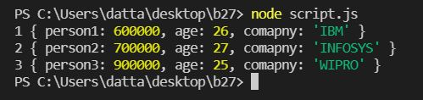

**For-each loop:**

**let details =**

**{**

**1 :{person1: 600000,"age": 26,"comapny":"IBM"},**

**2 : {person2: 700000,"age": 27,"comapny":"INFOSYS"},**

**3 : {person3: 900000,"age": 25,"comapny":"WIPRO"},**

**}**

**Object.keys(details).forEach(function (key, val) {**

**console.log(key);**

**});**



**Object.keys(details).forEach(function (key, val) {**

**console.log(details[key]);**

**});**



**Object.values(details).forEach(value=>{**

**console.log(value);**

**});**



**Object.keys(details).forEach(key=>{**

**console.log(key);**

**});**

